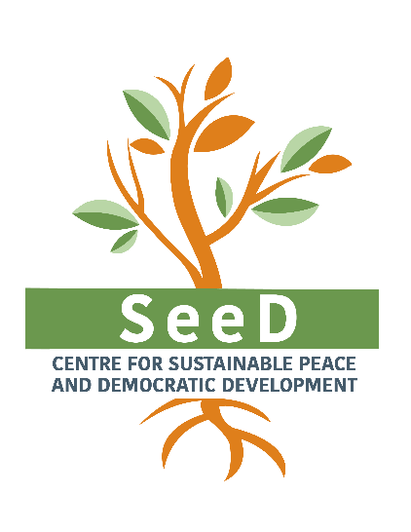
ADMINISTRATION AND OPERATIONS OFFICER

Position Description and Terms of Reference

Position title: Administration and Operations Officer
Duty station: SeeD office, Nicosia, Cyprus
Reports to: Administration and Finance Manager
Contract modality: Employment contract
Remuneration: An attractive remuneration package will be offered based on experience
Contract duration: Full-time employment renewed annually, with a probation period of 3 months.
Start date: 12th January 2023, desired starting date.

Deadline for applications: 19th December 2022, 09:30 am GTM+2

General background:

The Centre for Sustainable Peace and Democratic Development (SeeD) works with international development organisations, governments and civil society leaders to design and implement people-centered and evidence-based strategies for promoting peaceful, inclusive and resilient societies. Working in Europe, the Middle East, Africa and Asia, SeeD provides social transformation policy recommendations that are rooted in citizen engagement strategies and an empirical understanding of the behaviours of individuals, groups and communities. More information about SeeD can be found at: www.seedsofpeace.eu.

The Administration and Operations Officer will be a member of the Operations Unit of SeeD, which encompasses Finance, IT, Administration, Legal, Internal Audit and HR. The Operations Unit is led from the SeeD Headquarters office in Cyprus and provides service and support at all levels and regions where SeeD is working. Under regular supervision from the Administration and Finance Manager, the Administration and Operations Officer will contribute to an efficient and effective global operations function.

The successful candidate for this position will be able to demonstrate strong attention to detail, efficient implementation of standardized procedures, good problem-solving skills, good numerical skills, and proficiency in working both with people and teams as well as with information and documents. SeeD will provide ongoing training and support, to ensure the gradual and timely growth and development of the successful candidate that will benefit both the individual and the team. Ultimately, this position is open to professional growth for the right candidate that comes with strong institutional fit and growth mindset.

Duties and Responsibilities:

1. Office Administration and Operational Duties

- Facilitate the smooth flowing of routine, administrative work with due care for all applicable rules and regulations, including the coordination of provision of office supplies and other daily consumable needs of the Nicosia office;
- Maintain and respond to the SeeD phone and info@email account;
- Support internal institutional communications such as scheduling and minute taking at the Global Team Meetings; and record keeping and file sharing systems including but not limited to Dropbox and Microsoft Teams (access levels, archiving/labeling guidelines), G-Suite (Calendar and Google Analytics reports) and all institutional passwords;
- Support ad hoc operational, administrative and logistical requests at the HQ and regional team level (e.g., arranging travel, event planning, contracting, collecting quotations and bids for approved purchase requests);
- Oversee institutional memberships, subscriptions and platform profiles, keeping them and their login details up to date and secure (e.g., SAM; PADOR, ECAS, HORIZON, EU portal, Canva, Biteable etc.).

2. Financial Administration, Accounting and Cash Management

- Assist in the timely preparation of expense invoices and other relevant supporting documents for bookkeeping;
- Handle the monthly preparation of payments for processing via online banking, for the review and approval of the SeeD bank account authorized user / signing officer;
- Support the provision of routine information and documents to banking institutions in the context of ongoing business relationships
- Support the internal monthly financial reporting and management accounting cycle through the collection and compiling of supporting documentation and other relevant information;
- Contribute to the preparation and timely submission of relevant annual accounts, statements, income or tax returns and the audit engagements for corresponding authorities;
- Handle approved payments via the Petty Cash Fund, ensure full records are maintained and assist in periodic physical checks of fixed assets of the office.

3. Contracting and HR Administration

- Oversee contracting and coordinate successful personnel onboarding and set up, at the Cyprus office or remotely and globally;
- Maintain and track HR contracts and HR records including their duration, signature, filing, timesheet submission, up to date bios and CVs, usage of paid or unpaid absence, as well as harmonization with latest HR policies;
- Support the implementation of recruitment processes including preparation of terms of references, vacancy announcements, correspondence with candidates, application administration checks and filtering, reference collection and so forth;
- Support the maintenance of appropriate HR databases, including payroll transactions along with payroll updates such as new hires and changes to pay rates.

Knowledge, Skills and Experience:

Essential
- Degree / diploma / or other relevant qualifications in Office Administration, or another related field
- Solid numerical and analytical skills and strong sense of attention to detail
- Working knowledge of Greek
- Excellent written and verbal communication skills in English
- Solid working knowledge of common software programs (e.g., Excel, Word, PowerPoint, Adobe etc.)
- Minimum 3 years demonstrable experience of handling similar operational tasks
- Strong organization, prioritization and problem-solving skills
- Strong sense of responsibility and thoroughness
- Strong commitment to peace, sustainable development and the principles of SeeD

Desirable
- Skills, training or experience related to the duties and responsibilities described above
- Skills, training or experience related to financial, project, operational and strategic planning
- Working knowledge of some accounting software (preferably QuickBooks) and project, HR and time management applications
- Previous experience in donor funded programmes and NGO work

Application Process:

1. Interested applicants should submit the following to recruitment@seedsofpeace.eu by 19th December 2022, 09:30 am GTM+2 (a) full CV including contact details and 2 references, and (b) a cover letter which clearly states (i) how you envision your role at SeeD, (ii) how your previous experience addresses the needs and responsibilities outlined for this position, (iii) your available start date.

2. Upon evaluation of CVs and responses, short-listed candidates will be invited for an interview in the second half of December 2022.

We thank all candidates for their interest, however only those selected for interviews will be contacted.

